SC Analyser 2005

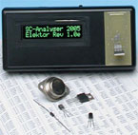
Semiconductor Device Tester
Almost every electronic circuit contains bipolar transistors, FETs or diodes. Most electronics hobbyists have a supply of such components removed from old circuit boards. A tester that can be used to sort out the leads and measure the characteristics is thus a handy tool.

Hyperlinks
www.mwinstruments.com
www.mwinstruments.com/SCA2005/sca2005.html
m.waleczek@mwinstruments.com
www.microchip.com/download/lit/pline/picmicro/families/16f87x/30292c.pdf

Extra information and/or updates
The parts list states a wrong enclosure; this should a Hammond type 1593YBK.
In the Components List on page 39, the order code for the programmed PIC (IC2) should be corrected to read: 030451-41.
Unfortunately, an early version of the PCB artwork is shown in Figure 5. Although it will produce a properly working instrument, the PCB design shown lacks the extra decoupling for the PLED display mentioned in the article. The PCB supplied through our Readers Services does have space and copper tracks for the extra decoupling network and comes with a corresponding note to customers.
Several readers have reported difficulties with the configuration bits to set up in the PIC. The confusion is owing to poorly defined standards at Microchip. Because all status bits are at ‘1’ with a new processor, there are options where ‘1’ means ‘enabled’, while for other options it means ‘disabled’. To add to the confusion, some programmer systems (including the one currently in use at Elektor labs) employ the notation ‘on’ and ‘off’.
The essential options are the oscillator, watchdog timer, low-voltage programming and in-circuit debugger. The following list provides the desired state for each option, where ‘0’ = unprogrammed and ‘1’ = programmed.
Options:
bit 13, CP: Flash Program Memory Code Protection bit; 1
bit 11, DEBUG: In-Circuit Debugger Mode bit; 1
bit 10-9, WRT1:WRT0 Flash Program Memory Write Enable bits; 11
bit 8, CPD: Data EEPROM Memory Code Protection bit; 1
bit 7, LVP: Low-Voltage (Single-Supply) In-Circuit Serial Programming Enable bit; 1
bit 6, BOREN: Brown-out Reset Enable bit; 1
bit 3, PWRTEN: Power-up Timer Enable bit; 0
bit 2, WDTEN: Watchdog Timer Enable bit; 0
bit 1-0, FOSC1:FOSC0: Oscillator Selection bits; 11

Parts list
Resistors:
R1,R5,R9 = 100kΩ, 1% R2,R6,R10,R13 = 5kΩ6
R3,R7,R11 = 1kΩ, 1% R4,R8,R12 = 100Ω, 1%
R14 = 47kΩ R15 = 33Ω
R16 = 27Ω P1 = 10kΩ preset
Capacitors:
C1,C3 = 10µF 25V radial C2,C5,C9 = 100nF
C4 = 100pF C6,C7,C8 = 1nF MKT
C10 = 10µF 16V radial
Semiconductors:
D1 = 1N4001 IC1 = 78L05
IC2 = PIC16F876-20/SP IC3,IC4,IC5 = 74HC4052 (HC only!)
Miscellaneous:
S1 = on/off slide switch LCD1 = standard LCD with 2x16 characters, e.g., ASI-G-162FS-GF-EWS/W (with backlight) or LCD 162C BL (P-LED with active backlight)
16-way SIL pinheader with mating connector, or flatcable for connection to display
JP1 = 2-way pinheader with jumper 3 mini croc clips

Schéma 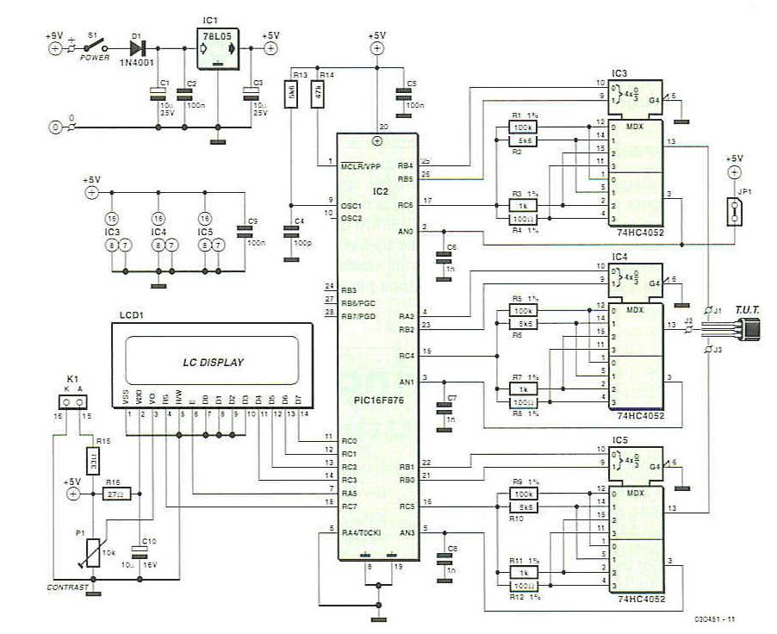

Free software
030451-11.zip

DPS
